INFOLABZ IT SERVICES PVT LTD

REACT | ASSIGNMENT 2 | 9 FEBRUARY 2024

**TASK 1 :**

**Webpage 1 :** Design a webpage with total 9 cards contains movie information as follow.

( apply card header , footer, image, body ) [Easy]

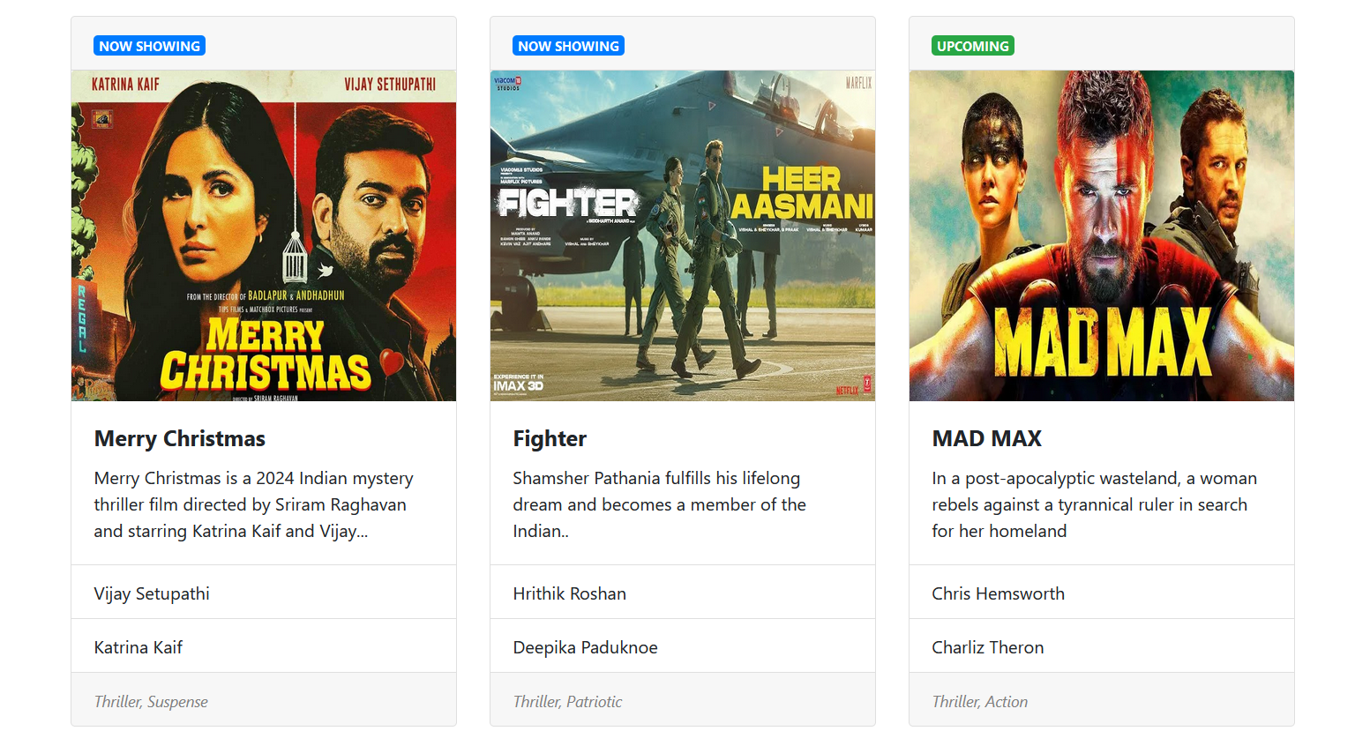

( Above web page contains 3 rows , each containing 3 cards. Total 9 movies information )

**TASK 2 :**

ISRO API : <https://isro.vercel.app/api/spacecrafts>

Load API data using JS ( async, await & fetch ) and print it in bootstrap table. [Easy]

Applied bootstrap concepts : Container, Row, Bordered table

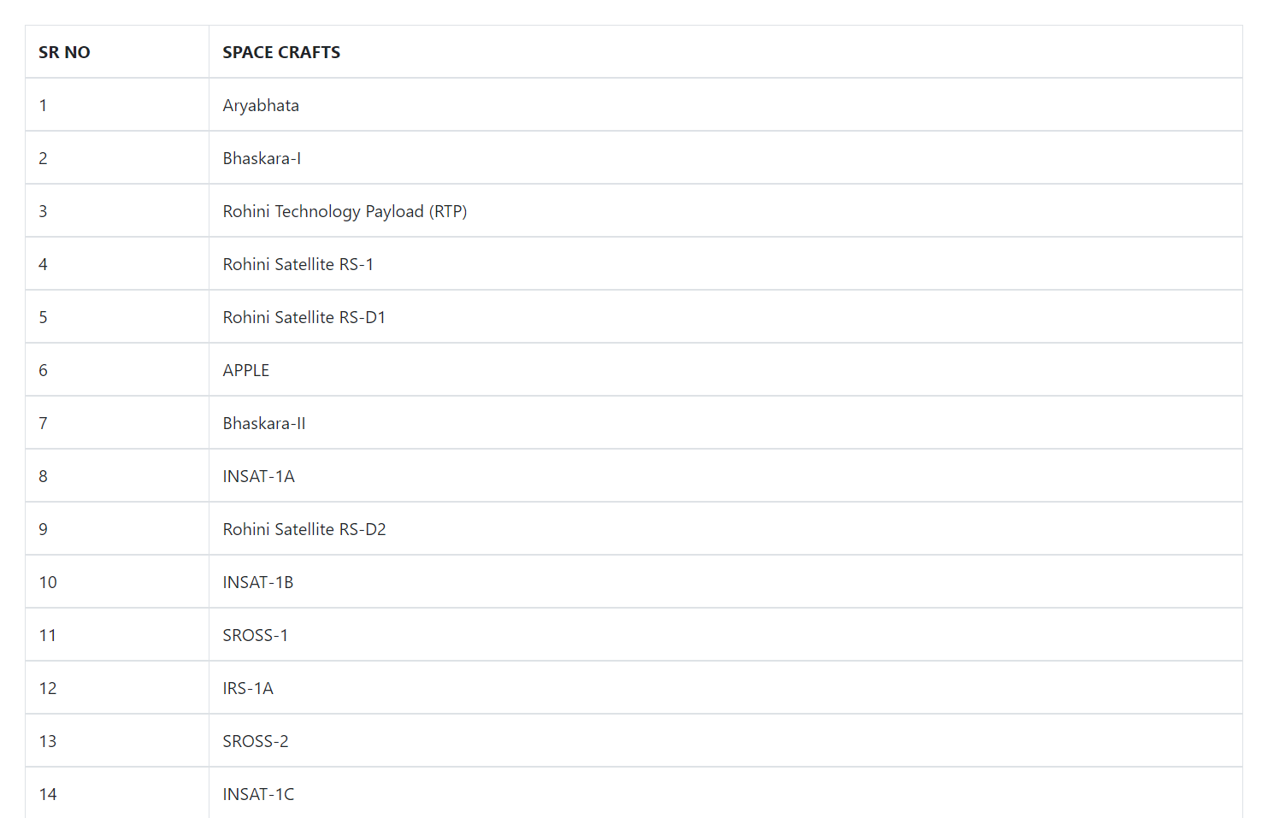

**TASK 3 : ( BASED ON ASSIGNMENT 1 )**

API : <https://inshortsapi.vercel.app/news?category=sports>

IN ASSIGNMENT WE HAVE LOAD NEWS API DATA IN HTML TABLE. CONVERT IT TO BOOTSTRAP TABLE AS SHOWN BELOW. [ MODERATE ]

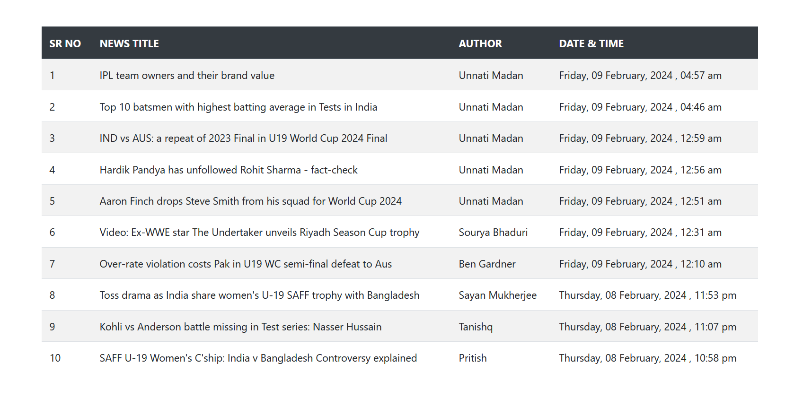

**TASK 4 : COMBINATION OF TASK 1 AND TASK 3**

API : <https://inshorts.vercel.app/news/top>

LOAD API DATA FROM NEWS API IN ABOVE CREATED BOOTSTRAP CARDS

[ DIFFICULT ]

